

**SCHOOL OF COMPUTATIONAL SCIENCE**

**SWAMI RAMANAND TEERTH MARATHWADA UNIVERSITY**

**NANDED (MAHARASHTRA) – 431606**

**YEAR 2024-25**

**“EDUCONNECT: EDUCATIONAL AND PLACEMENT HUB”**

**1. Muskan Mahveen Syed Sadullah**

**2. Chudiwale Alfiya Abdul Sattar**

**3. Momin Reshma Jabbar**

**(Msc CA & CS)**

***In partial fulfilment for the award of the degree of***

***MSC ( Computer Application & Science)***

**Guided by Director**

**Dr. Parag Bhalchandra sir Dr. G V Choudhary**

**Objectives**

1. **Centralized Information Platform:**  
   Develop a unified system to consolidate and manage academic information, research opportunities, placement details, and job advertisements in one place.
2. **Enhancing Accessibility:**  
   Provide students, educators, and placement coordinators with a mobile-friendly and web-accessible platform to simplify data retrieval and interaction.
3. **Facilitating Career Growth:**  
   Streamline access to placement drives, internships, and job vacancies, enabling students to explore and secure career opportunities efficiently.
4. **Encouraging Collaboration:**  
   Promote research and collaboration by showcasing scholarships, research projects, and opportunities for teamwork between students, educators, and institutions.
5. **Motivational Content:**  
   Create a positive and inspiring environment by including a section dedicated to motivational quotes, success stories, and educational growth tips.
6. **Ease of Use:**  
   Design an intuitive user interface with a seamless experience for uploading, viewing, and managing data across mobile and web platforms.
7. **Global Reach:**  
   Leverage the Google Play Store to make the application accessible to a wide audience, ensuring its adoption across diverse demographics and regions.
8. **Data Security:**  
   Implement robust security measures to protect sensitive academic and placement data, ensuring privacy and reliability for users.
9. **Dynamic Updates:**  
   Allow real-time updates for schedules, vacancies, research projects, and other data, ensuring users always have access to the latest information.
10. **Building a Professional Network:**  
    Encourage communication and networking between students, educators, and industry professionals to create a supportive and productive ecosystem.

**Abstract**

EduConnect is a comprehensive application designed to bridge the gap between educational institutions, students, and placement/recruitment agencies. The application will allow users (students, educators, and placement coordinators) to easily upload, view, and interact with the following types of data:

1. Academic Information: Universities, courses, exams, schedules, etc.

2. Research Opportunities: Available research projects, scholarships, and collaborative research options.

3. Placements: Job vacancies, internship opportunities, placement drives, etc.

4. Requirement Advertisement: Industry-specific job requirements and hiring advertisements.

5. Noble Thoughts: A section for motivational quotes, success stories, and inspirational content related to education and career growth. The application will be available for download from the Google Play Store, making it accessible to students and professionals across various regions. It will utilize both a mobile app interface (using Java for Android) and a backend server (using HTML for the web interface) to facilitate data entry and retrieval.

**Introduction**

1. EduConnect is a modern, user-friendly application designed to serve as a comprehensive platform connecting educational institutions, students, and placement/recruitment agencies. This application bridges the information gap, ensuring seamless access to academic, research, and career opportunities. By providing an integrated system, EduConnect caters to the needs of students, educators, and industry professionals, creating a collaborative environment where information is easily shared and accessed.
2. With a mobile-first approach, the application leverages Java for Android to provide a smooth user experience, and an HTML-based web interface for administrators and coordinators to manage data efficiently. EduConnect aims to empower its users by making crucial academic, research, and placement-related data accessible at their fingertips. Additionally, it fosters motivation and career development by including inspirational content in its "Noble Thoughts" section.
3. EduConnect will be available on the Google Play Store, ensuring accessibility to a diverse range of users across various regions, helping them stay informed and connected in an ever-evolving educational and professional landscape.
   * .

**Key Features**

• User Registration and Login: Secure user registration/login for students, educators, and industry professionals.

• Data Upload/Insert: A user-friendly interface for uploading data related to academic programs, research opportunities, placements, job advertisements, and noble thoughts.

• Notifications: Real-time updates and notifications about new opportunities.

• Search Functionality: Ability to search through academic programs, job postings, and research opportunities.

• Admin Panel: For managing and moderating data.

**Technologies Used**

• Frontend (Mobile): Java (Android SDK) for the app's user interface.

• Backend (Server): HTML, CSS, JavaScript for web interface; MySQL or Firebase for database management; PHP or Node.js for server-side processing.

• Cloud Hosting: For storing and retrieving large datasets (Firebase or AWS).

• Push Notifications: For real-time updates.

**Flowchart**

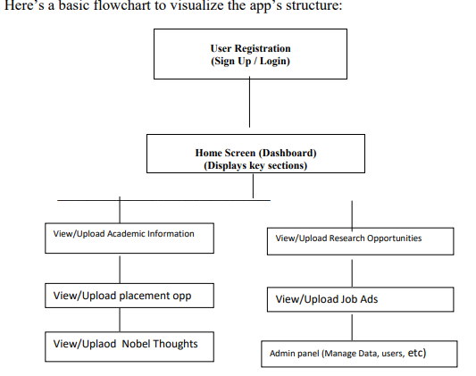

**Steps Flow**

1. User Registration/Login: A new user registers by filling in their credentials, and existing users log in with their credentials.

2. Home Screen/Dashboard: Once logged in, the user is redirected to the home screen, where they can see a summary of all available sections: Academic Information, Research Opportunities, Placements, Job Ads, and Noble Thoughts.

3. View/Upload Data: o Users can choose any section to either view available content or upload new content (based on their role). o For uploading, they fill in the required fields (e.g., course details, job descriptions, research project outlines) and submit.

4. Admin Panel: Admins can manage all the data and users through the admin panel. They can approve, delete, or edit the uploaded information.

5. Push Notifications: When new data is uploaded, or when there are updates, users will receive push notifications to stay informed.

**Conclusion**

The EduConnect application will provide a centralized platform for students and professionals to access essential academic, research, placement, and motivational information. With seamless interaction between the mobile app and the web-based server, the system will ensure smooth data handling and provide an intuitive user experience.

**Team Members:**

**Muskan Mahveen Syed Sadullah**

**Chudiwale Alfiya Abdul Sattar**

**Momin Reshma Jabbar**

**SCHOOL OF COMPUTATIONAL SCIENCE**

**SWAMI RAMANAND TEERTH MARATHWADA UNIVERSITY**

**NANDED (MAHARASHTRA) – 431606**

**YEAR 2024-25**

**Project Title:**

**“EDUCONNECT: EDUCATIONAL AND PLACEMENT HUB”**

**Submitted By:**

**1. Muskan Mahveen Syed Sadullah**

**2. Chudiwale Alfiya Abdul Sattar**

**3. Momin Reshma Jabbar**

(M.Sc. Computer Application & Science)

**Guided By:**

**Approved By:**

1. Project Coordinator:  
   Name: _______________________  
   Signature: __________________
2. Director:  
   Name: _______________________  
   Signature: _________________

3 Date of Approval: